Cancer Research Division
PhD STUDENT COMMITTEE REPORT
STUDENT NAME: Peter Donnelly
MEETING DATE: 2 Dec 2019 | VENUE: PMCC Meeting Room 11.214
COMMITTEE: Student Committee 4
SUPERVISORS: Dr Ken Doig and Dr Thomas Conway
MENTOR: Dr Huiling Xu
LENGTH OF CANDIDATURE TO DATE: 8 months
PROJECT TITLE: ‘Improving Classification of T-Cell Lymphomas By Applying Machine Learning to Heterogeneous Data Types’
COMMITTEE MEMBERS PRESENT (TBC):
Chair: Prof David Bowtell, Co-Chair: Dr David Goode, Dr Carleen Cullinane,
Dr Luc Furic, Dr Omer Gilan, Dr Rae Farnsworth

For the 1st (6 month) Committee review meeting
  - Provide key background information (and references as appropriate) that has led to the definition of your project’s aims.
The idea for my project came out of a discussion between Dr Kenneth Doig and Dr Piers Blombery.
Hypothesis:
- A multi-modal neural network trained with heterogeneous data types (WSI images + gene expression data) may be an effective tool for automatically classifying Lymphomas (generally), and difficult to classify T-Cell Lymphomas in particular
The logic underpinning the project is as follows:
- Pathologists find it challenging to classify some Lymphoma subtypes; Peripheral T-Cell Lymphoma (PTCL) as a particular example. Inter- and Intra-pathologist variability can be quite high for PTCL.
- Machine Learning has been making rapid progress since about 2010 (see Figure 1 below). Deep Learning Networks have show great early promise in classifying cancers from histopathology images and are on the cusp of becoming clinically relevant, however ML efforts in diagnostic pathology still mostly focus on low hanging fruit: easier to classify cancers; and opportunistically where good labelled data for use in training happens to be available.

Kamath U., Liu J., Whitaker J. (2019) Introduction. In: Deep Learning for NLP and Speech Recognition, Springer
Figure 1: Machine Learning Chronology
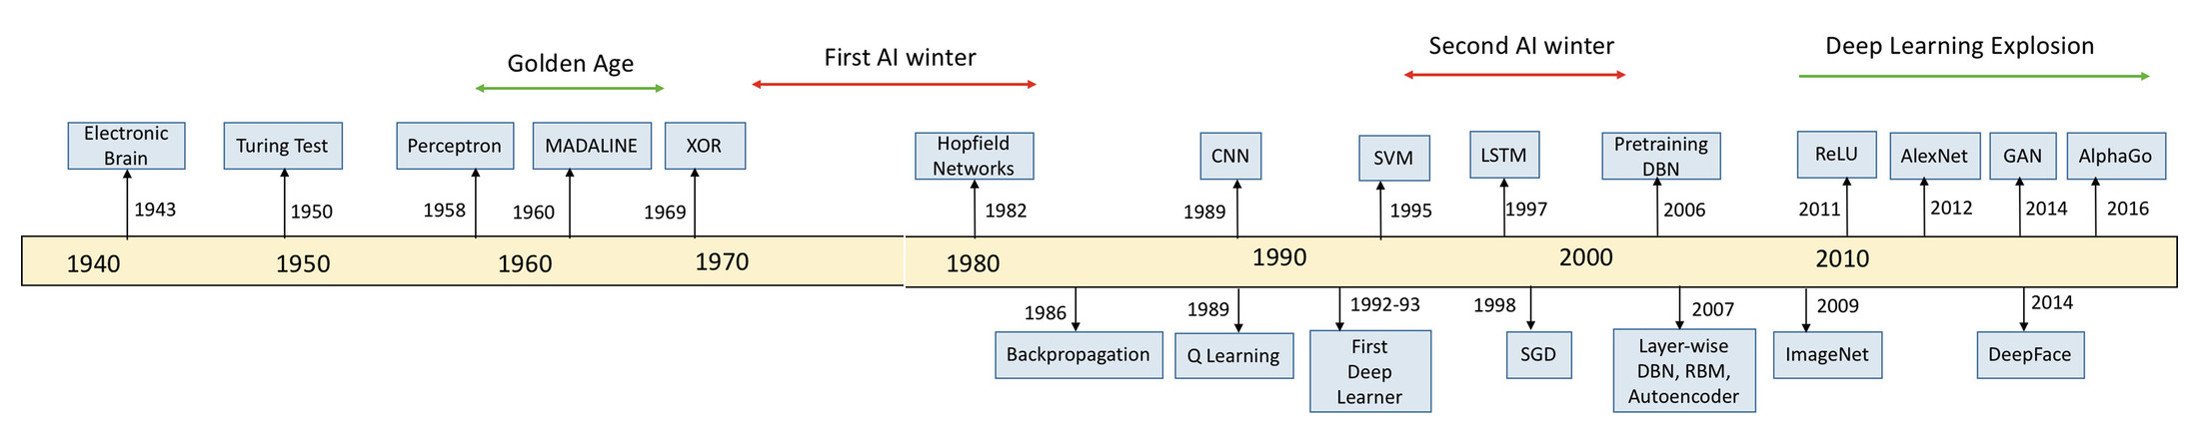
- The high road to obtaining good results from ML entails high quality, consistently labelled training data, but such data is scarce in the domains of interest
  - Large public datasets are frequently large numbers of collections of small datasets, often quite diverse in origin, scope and quality
  - While ML techniques exist which can amplify the effectiveness of less than perfect data, these are only occasionally used in practice.
    - Multi-modal Learning; which allows learning from more than one data type simultaneously (e.g. Image data + gene expression data)
    - Multiple Instance Learning; which uses aggregated training data labels. (e.g. single end diagnosis as the label for each of thousands of tiles from a WSI)
  - These and other techniques could beneficially be applied to the problem of classifying Lymphoma sub-types.
Further Assumptions relevant to the project are as follows:
- Gene expression testing (Microarrays, RNASeq, Nanostring) will ultimately become routine clinical tests for all cancer patients.
- Ultimately, purely manual analysis of bio-specimens will not be sustainable due to the enormous volumes of images and data which are being generated
- Publicly accessible, labelled WSI and genomic datasets have passed the threshold of viability for use with Machine Learning (number of labelled examples, quality of examples), and will only become more extensive and useful with time.
- ML models are accretive & once successfully developed can be disseminated at very low cost
Identified Issues, Risks, Ameliorations are as follows:
- Unable to obtain access to suitable PMCC clinical data for some reason
Risk level: unknown
Impact: moderate
Amelioration: drop Aim 3 and rely on public data
- PMCC gene expression data is not available in time, or at all
Risk level: unknown
Impact: moderate
Ameliorations:
(i) micro-array or RNAseq data might alternatively be available
(ii) drop Aim 3 and rely on public data
- The ML techniques I use might not work. E.g. algorithms may not be able to extract sufficient signal from images to combine with gene expression data
Risk level: medium to high
Impact: severe
Ameliorations:
(i) change Aim 2 to target something outside the Lymphoma domain
(ii) drop Aims 2 & 3 and hope to achieve something worthwhile in the Image-only or genomic-only domain
- It’s ambitious: there might not be sufficient time to complete all of the stated aims
Risk level: medium to high
Impact: moderate
Amelioration: cut back or modify aims in some TBD fashion

  - Are the topic and aims now well defined? What are the aims?

Yes.

Aim 1: Establish a baseline toolchain using mainstream machine learning models and use to test the hypothesis on ‘easy’ data, viz: publicly available autopsy and B-Cell lymphoma data from The Cancer Genome Atlas (TCGA) and The Genotype-Tissue Expression (GTEx) project

Aim 2: Develop and validate and test a multi-modal learning network that is able to classify ‘difficult’ data; viz: PMCC B-Cell and T-Cell Lymphoma samples and thereby fully test the hypothesis.

Aim 3: Clinical Translation: Convert the learning network resulting from Aim 2 into a useful, usable and clinically relevant support tool for Curators and Pathologists.
A Project Plan corresponding to the three aims can be found in the response to question 9 below.

  - Are the appropriate methods for your project established?

Yes. The primary method of addressing the study aim(s) will be through the use, adaptation and customization of contemporary machine learning architectures, algorithms and techniques in combination with publicly available databases such as TCGA, Camelyon and GTE which hold whole slide image (WSI) data and gene expression data.

More specifically, it may be that a supervised deep learning network will prove suitable if it makes use of (i) Multi-modal learning, to enable it to learn simultaneously from both image data and gene expression data, and (ii) Multiple Instance Learning to allow a single label (i.e. the true classification) to be applied to multiple inputs (i.e. the collection of image tiles and gene expression levels corresponding to a single sample/example).
The image aspect of the network is likely make use of one of the well known CNN architectures such as ‘ResNet’ or ‘Inception’. The gene expression aspect of the model may comprise a simple linear embedding. It may be necessary to make use of more sophisticated techniques, such as Deep Canonical Correlation, to extract comparable vector embeddings from each data modality.

The above should be seen as a going-in hypothesis. The learning network actually used may differ markedly from this as a result of practical and probably messy experience gained during development.

  - Do you have a good understanding of the literature relevant to your project?

Response Part 1
Yes. I have reviewed a large number of papers relevant to my project and made structured summaries of the most useful and relevant of those papers. Click on the icon below to view these. I will continue to review relevant papers during the course of my thesis.


Response Part 2
Figure 2 attempts to map the relevant portion of the literature landscape. It is based on a ‘scan’ level review of approximately 100 journal articles and a more complete structured review of the 36 articles identified and summarised in the above spreadsheet.
The red rectangle groups the most common projects seen; assessed using the five ‘aspects’ listed on the left. The green rectangles identifies my proposed project with 4/5 of the same aspects.
Although substantial diversity is observable in the totality of reviewed papers, a distinct ‘sweet spot’ exists into which most papers/project fall (red rectangle), viz: most researchers are applying Convolutional Neural Networks (CNN) to digitized histopathology images with the goal of identifying and classifying (i) breast cancers (mainly via metastases) or alternatively, (ii) identifying and classifying multiple types of cancers (one project attempts to detect and classify 27 different cancer types). Outside the sweet spot, overlap among projects is not common – most of those papers tackle a unique combination of the five aspects listed.
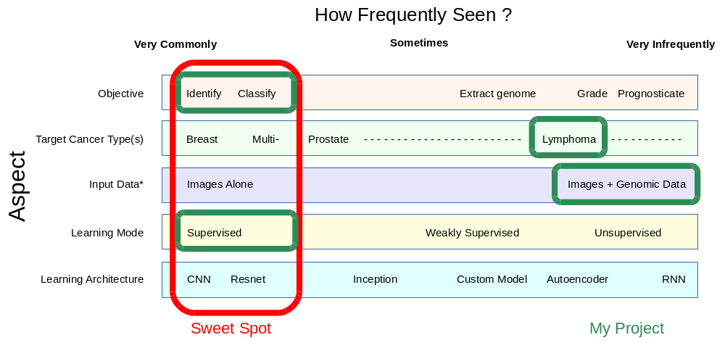Figure 2: Literature Landscape: What Are Others Focusing On ?`
No project was seen to be tackling the same subject area as my thesis, however the application of ML to cancer histopathology and genomics is an area of intense interest, so this situation could easily change during the course of my PhD. The nearest project to my thesis is one which attempts to recreate gene expression from morphology (‘End-to-end training of deep probabilistic CCA on paired biomedical observations’, Gundersen et al, NIPS 2018). This paper which instantiates and validates a means of extracting the common ‘signal’ from dual data types, is highly relevant to my work, and I have communicated with the project’s lead author.
Response Part 3
Key motivating papers
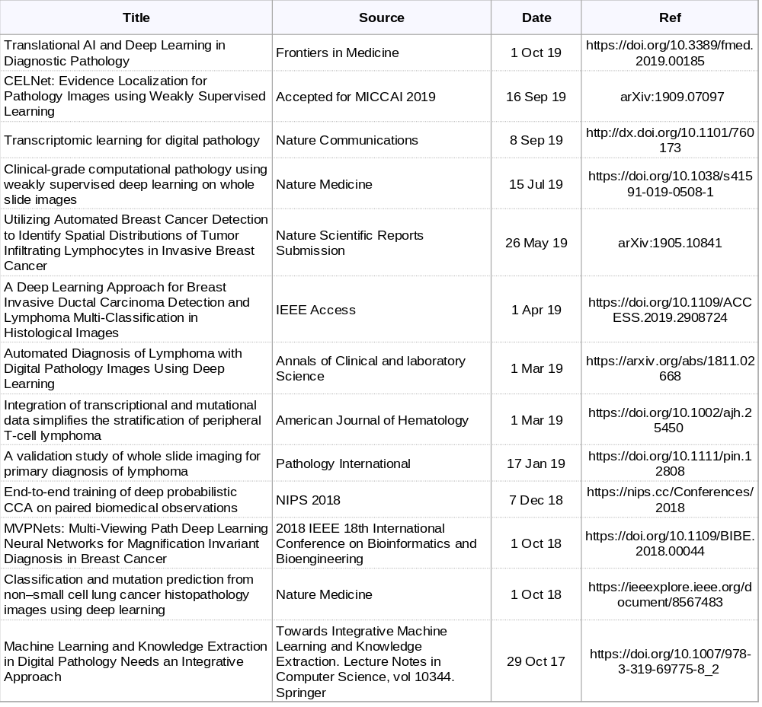
  - How good are you at finding help (technical or academic) when your project calls for it?

I have some relationships with the Peter Mac researchers as well as many colleagues in the software engineering industry whose expertise I am able to draw on. I have contacted and received replies from authors of papers relevant to my project.

I expect that I will need assistance with the statistical analyses that will form an important part of Stage 3 in particular.

  - Have any problems been encountered which need to be resolved?

Not at this stage.

  - Do you have any plans for publications or conference presentations related to your project ? (present a plan if you think it would be helpful)

Yes, but I am not in a position yet to be specific.

Possible first author papers:

- Review Paper: Extracting Common Signals from Heterogeneous Biological Specimen Data
- A Multi-model Deep Learning Model for Classifying Lymphomas

  - Are there any issues you wish to discuss with your committee?

No specific issues, however it is an ambitious project for which success is far from guaranteed, so I welcome any guidance that the committee may be able to provide.

  - Are the short and long term experiments clearly mapped out?

Yes. See Figure 3
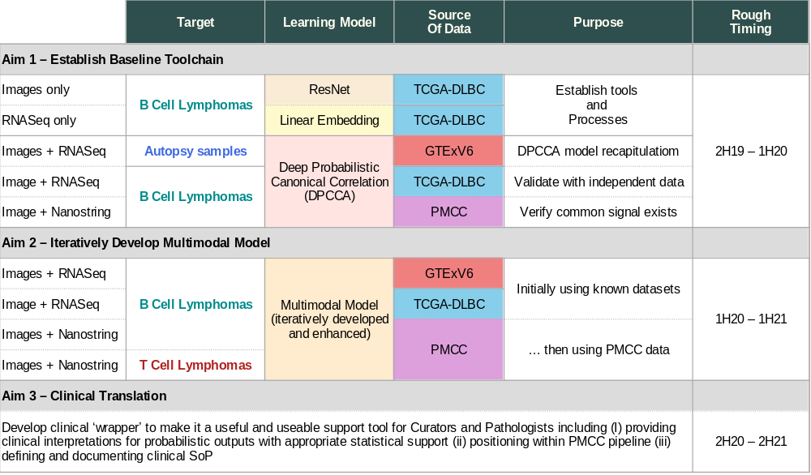

  - Do you have a time line to show?

Yes. See response to 9 above

  - Overall, do you think you are on track with your project?

Yes.

  - Committee Comments/Report (to be completed by Mentor after the meeting):

Research Training in past year

Attach a summary sheet for the research training activities highlighting the activities you participated in since commencing, including details of any of the following:
- Induction and Orientation program
- Specialist laboratory skills training
- Hub, Lab meetings and Journal clubs
- Seminar and workshop programs
- Annual Student Retreat
- Topics in Cancer program
- Research Seminar program
- Research lunches attended
- Research Governance program
- Research reporting (Presentations, written reports submitted etc)
- Technical seminars

‘ResNets’ (Residual Networks) are a variant of Convolutional Neural Networks which allow for training to ‘skip’ one or more layers

